KAVAYITRI BAHINABAI CHAUDHARI
NORTH MAHARASHTRA UNIVERSITY,
JALGAON.

SCHOOL OF MATHEMATICAL SCIENCES
(DEPARTMENT OF STATISTICS)

AC - 301 (INTRODUCTION TO SAS)
2111- Ghogare Sachin
SAS Project

CONTENTS:
- Logistic Regression
- ANOVA Model

INTRODUCTION
In this session we are using the Logistic regression model for class data in sas library.
The main objective of this model is to predict the age of a person by using his Height and Weight variable. I have classify the people by their Gender into two categories.

Q. What is Logistic Regression ?
Answer:
Logistic regression, also called a logit model ,It is used to predict the result of a categorical dependent variable based on one or more continuous or categorical independent variables. In other words, it is multiple regression analysis but with a dependent variable is categorical.
Fraud Detection
Diseases Diagnosis
Spam mail detection
Linear Regression Vs Logistic Regression
Linear Regression and Logistic Regression are the two famous Machine Learning Algorithms which come under supervised learning technique. Since both the algorithms are of supervised in nature hence these algorithms use labeled dataset to make the predictions. But the main difference between them is how they are being used. The Linear Regression is used for solving Regression problems whereas Logistic Regression is used for solving the Classification problems.
Logistic regression is one of the most popular Machine learning algorithm that comes under Supervised Learning techniques. It can be used for Classification as well as for Regression problems, but mainly used for Classification problems. Logistic regression is used to predict the categorical dependent variable with the help of independent variables. The output of Logistic Regression problem can be only between the 0 and 1. Logistic regression can be used where the probabilities between two classes is required. Such as whether it will rain today or not, either 0 or 1, true or false etc.
SAS Code :
ods noproctitle;
ods graphics / imagemap=on;
proc qlim data=SASHELP.CLASS;
class Sex;
model Age=Height Weight Sex / discrete(distribution=logistic) limit1=zero;
run;
output:
Discrete Response Profile of Age
Index | Value | Total Frequency
1 | 11 | 2
2 | 12 | 5
3 | 13 | 3
4 | 14 | 4
5 | 15 | 4
6 | 16 | 1

Class Level Information
Class | Levels | Values
Sex | 2 | F M

Model Fit Summary
Number of Endogenous Variables | 1
Endogenous Variable | Age
Number of Observations | 19
Log Likelihood | -19.36000
Maximum Absolute Gradient | 4.08869E-6
Number of Iterations | 34
Optimization Method | Quasi-Newton
AIC | 54.71999
Schwarz Criterion | 62.27551

Goodness-of-Fit Measures
Measure | Value | Formula
N = # of observations, K = # of regressors
Likelihood Ratio (R) | 25.529 | 2 * (LogL - LogL0)
Upper Bound of R (U) | 64.249 | - 2 * LogL0
Aldrich-Nelson | 0.5733 | R / (R+N)
Cragg-Uhler 1 | 0.7391 | 1 - exp(-R/N)
Cragg-Uhler 2 | 0.7651 | (1-exp(-R/N)) / (1-exp(-U/N))
Estrella | 0.8196 | 1 - (1-R/U)^(U/N)
Adjusted Estrella | 0.4189 | 1 - ((LogL-K)/LogL0)^(-2/N*LogL0)
McFadden's LRI | 0.3973 | R / U
Veall-Zimmermann | 0.7429 | (R * (U+N)) / (U * (R+N))
McKelvey-Zavoina | 0.9182

Algorithm converged.
Parameter Estimates
Parameter |  | DF | Estimate | Standard  Error | t Value | Approx  Pr > |t|
Intercept |  | 1 | -28.342341 | 10.656924 | -2.66 | 0.0078
Height |  | 1 | 0.389589 | 0.218148 | 1.79 | 0.0741
Weight |  | 1 | 0.079967 | 0.052060 | 1.54 | 0.1245
Sex | F | 1 | 1.883490 | 1.070918 | 1.76 | 0.0786
Sex | M | 0 | 0 | . | . | .
_Limit2 |  | 1 | 3.402728 | 1.361779 | 2.50 | 0.0125
_Limit3 |  | 1 | 5.003126 | 1.601546 | 3.12 | 0.0018
_Limit4 |  | 1 | 7.110893 | 1.865960 | 3.81 | 0.0001
_Limit5 |  | 1 | 10.827938 | 2.753172 | 3.93 | <.0001

Correlation of Parameter Estimates
 | Intercept | Height | Weight | Sex F | _Limit2 | _Limit3 | _Limit4 | _Limit5
Intercept | 1.0000 | -0.9361 | 0.3084 | -0.3257 | -0.3424 | -0.5030 | -0.5545 | -0.4806
Height | -0.9361 | 1.0000 | -0.6130 | 0.1570 | 0.3208 | 0.4433 | 0.4370 | 0.3033
Weight | 0.3084 | -0.6130 | 1.0000 | 0.2583 | 0.0565 | 0.0739 | 0.1981 | 0.3671
Sex F | -0.3257 | 0.1570 | 0.2583 | 1.0000 | 0.2952 | 0.3643 | 0.4053 | 0.3432
_Limit2 | -0.3424 | 0.3208 | 0.0565 | 0.2952 | 1.0000 | 0.8377 | 0.7539 | 0.5899
_Limit3 | -0.5030 | 0.4433 | 0.0739 | 0.3643 | 0.8377 | 1.0000 | 0.8633 | 0.6870
_Limit4 | -0.5545 | 0.4370 | 0.1981 | 0.4053 | 0.7539 | 0.8633 | 1.0000 | 0.7772
_Limit5 | -0.4806 | 0.3033 | 0.3671 | 0.3432 | 0.5899 | 0.6870 | 0.7772 | 1.0000

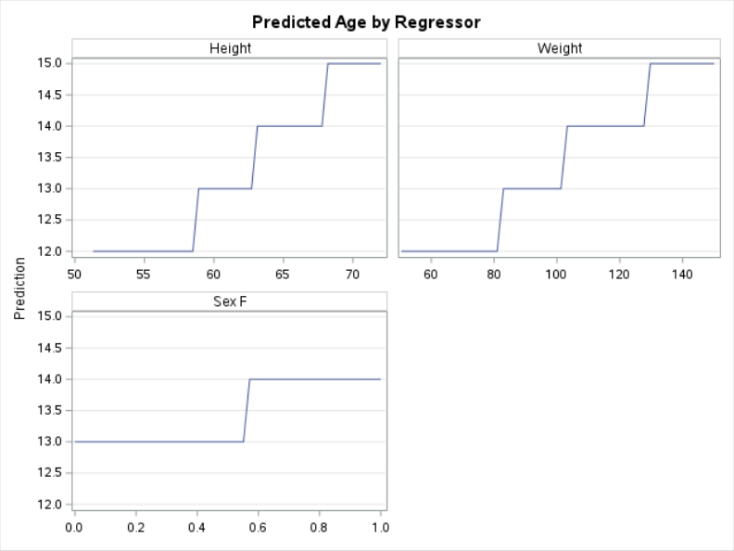
Conclusion:
We have fitted the logistic regression model to the above data to predict the age of a person. Our model predicted well for the data. As we can see for the height between 58 to 63 the age is 13.
ANOVA Model
Introduction
In this session we are using ‘BWEIGHT’ data from sashelp library. Our objective is to answer the below questin using anova model.
So our question is Does a mother’s education level(0,1,2,3) impact the number of parental visits ?

Q.What Is Analysis of Variance (ANOVA)?
Analysis of Variance (ANOVA) is a statistical formula used to compare variances across the means (or average) of different groups.Analysis of variance (ANOVA) is an analysis tool used in statistics that splits an observed aggregate variability found inside a data set into two parts: systematic factors and random factors. The systematic factors have a statistical influence on the given data set, while the random factors do not. Analysts use the ANOVA test to determine the influence that independent variables have on the dependent variable in a regression study.
The t- and Z-test Method developed in the 20th century were used for statistical analysis until 1918, when Ronald Fisher created the analysis of variance method.
ANOVA is also called the Fisher analysis of variance, and it is the extension of the t- and z-tests. The term became well-known in 1925, after appearing in Fisher's book, "Statistical Methods for Research Workers. It was employed in experimental psychology and later expanded to subjects that were more complex.

Steps Performing ANOVA Model:
So in this case we are comparing four levels of a mother’s education level with prenatal visits.
Define Null and Alternative Hypothesis:
Null Hypothesis = H0 : No difference between group means.
Alternative Hypothesis = H1 : There is a difference between at least two of
the group means.
Decide the Level of Significance:
We have fix the level of significance at 0.05 level.
Decision Criteria:
If the p-value is less than the level of sifnificance then reject the null hypothesis.
SAS Code to perform ANOVA:
Check some information about the our data.
proc contents data=sashelp.BWEIGHT;
Output:
Alphabetic List of Variables and Attributes
# | Variable | Type | Len | Label
2 | Black | Num | 8 | Black Mother
4 | Boy | Num | 8 | Baby Boy
7 | CigsPerDay | Num | 8 | Cigarettes Per Day
3 | Married | Num | 8 | Married Mother
5 | MomAge | Num | 8 | Mother's Age
10 | MomEdLevel | Num | 8 | Mother's Education Level
6 | MomSmoke | Num | 8 | Smoking Mother
8 | MomWtGain | Num | 8 | Mother's Pregnancy Weight Gain
9 | Visit | Num | 8 | Prenatal Visit
1 | Weight | Num | 8 | Infant Birth Weight
Now perform the ANOVA for the given data:
proc anova data=sashelp.BWEIGHT;
class MomEdLevel;
Model Visit = MomEdLevel;
run;
Output:

Class Level Information
Class | Levels | Values
MomEdLevel | 4 | 0 1 2 3

Number of Observations Read | 50000
Number of Observations Used | 50000

Dependent Variable: Visit Prenatal Visit
Source | DF | Sum of Squares | Mean Square | F Value | Pr > F
Model | 3 | 1337.32727 | 445.77576 | 918.71 | <.0001
Error | 49996 | 24259.07271 | 0.48522
Corrected Total | 49999 | 25596.39998

R-Square | Coeff Var | Root MSE | Visit Mean
0.052247 | 25.79936 | 0.696578 | 2.699980

Source | DF | Anova SS | Mean Square | F Value | Pr > F
MomEdLevel | 3 | 1337.327274 | 445.775758 | 918.71 | <.0001

Decision:
Our P-value is less than 0.05 therefore we are going to reject the null hypothesis. So that means there is a difference between at least two of the levels. Now we must check that which are those levels who is having the difference in their levels. For this we are going to use ‘tukeys’ test.
Tukeys Test :
- Tells you what groups have different means.
- Compares all possible means.
- Different Tukey tests ( Tukey-Crammer for unequal variance among groups).
SAS Code:
proc anova data=sashelp.BWEIGHT;
class MomEdLevel;
Model Visit = MomEdLevel;
means MomEdLevel/tukey;
run;
Output :
Class Level Information
Class | Levels | Values
MomEdLevel | 4 | 0 1 2 3

Number of Observations Read | 50000
Number of Observations Used | 50000

Dependent Variable: Visit Prenatal Visit
Source | DF | Sum of Squares | Mean Square | F Value | Pr > F
Model | 3 | 1337.32727 | 445.77576 | 918.71 | <.0001
Error | 49996 | 24259.07271 | 0.48522
Corrected Total | 49999 | 25596.39998

R-Square | Coeff Var | Root MSE | Visit Mean
0.052247 | 25.79936 | 0.696578 | 2.699980

Source | DF | Anova SS | Mean Square | F Value | Pr > F
MomEdLevel | 3 | 1337.327274 | 445.775758 | 918.71 | <.0001

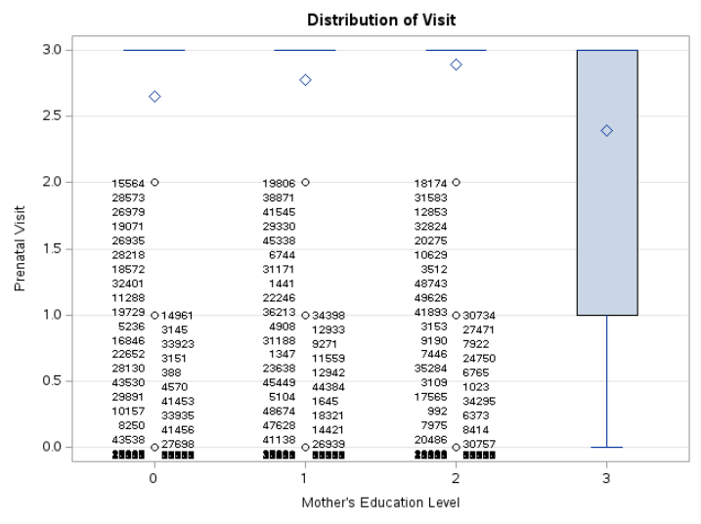
Tukey's Studentized Range (HSD) Test for Visit
Note:This test controls the Type I experimentwise error rate.
Alpha | 0.05
Error Degrees of Freedom | 49996
Error Mean Square | 0.48522
Critical Value of Studentized Range | 3.63327

Comparisons significant at the 0.05 level are indicated by ***.
MomEdLevel  Comparison | Difference  Between  Means | Simultaneous 95% Confidence Limits
2 - 1 | 0.121164 | 0.098332 | 0.143996 | ***
2 - 0 | 0.245003 | 0.224008 | 0.265998 | ***
2 - 3 | 0.502562 | 0.476892 | 0.528232 | ***
1 - 2 | -0.121164 | -0.143996 | -0.098332 | ***
1 - 0 | 0.123839 | 0.102683 | 0.144995 | ***
1 - 3 | 0.381398 | 0.355597 | 0.407200 | ***
0 - 2 | -0.245003 | -0.265998 | -0.224008 | ***
0 - 1 | -0.123839 | -0.144995 | -0.102683 | ***
0 - 3 | 0.257559 | 0.233368 | 0.281750 | ***
3 - 2 | -0.502562 | -0.528232 | -0.476892 | ***
3 - 1 | -0.381398 | -0.407200 | -0.355597 | ***
3 - 0 | -0.257559 | -0.281750 | -0.233368 | ***

Decision:
From the above output we can say that there is a significant difference between all the levels.

